Machine Learning Project Report

**Chatbots**

horizontal line

# 



**DELHI TECHNOLOGICAL UNIVERSITY**

**PROJECT REPORT**

**Submitted By: Submitted To:**

Abhishek Kumar (2K19/CO/020)Kavinder Singh

Abhishek Kumar Singh (2K19/CO/021)

**DELHI TECHNOLOGICAL UNIVERSITY**

(Formerly Delhi College of Engineering)

Bawana Road, Delhi - 110042

**CANDIDATE’S DECLARATION**

We, Abhishek Kumar, Abhishek Kumar Singh, Roll No(s). 2K19/CO/020, 2K19/CO/021, students of B.Tech. Computer Science & Engineering, hereby declare that the project Dissertation titled “**Chatbots”** which is submitted by us to the Department of Computer Science & Engineering, Delhi Technological University, Delhi in partial fulfillment of the requirement for the award of the mid-semester component evaluation, semester-5 of Bachelor of Technology is original and not copied from any source without proper citation. This work has not previously formed a basis for the award of any Degree, Diploma Associateship, Fellowship, or any similar title or recognition.

Place: Delhi Abhishek Kumar

Date: 17/11/2021 Abhishek Kumar Singh

**Department of Computer Science & Engineering**

DELHI TECHNOLOGICAL UNIVERSITY

(Formerly Delhi College of Engineering)

Bawana Road, Delhi - 110042

**CERTIFICATE**

We hereby declare that the project Dissertation titled “**Chatbots**” which is submitted by Abhishek Kumar, Abhishek Kumar Singh, Roll No(s). 2K19/CO/020, 2K19/CO/021, Department of Computer Science & Engineering, Delhi Technological University, Delhi in partial fulfillment of the requirement for the award of the mid-semester component evaluation, semester-5 of Bachelor of Technology, is a record of the project work carried out by the students under my supervision. To the best of my knowledge this work has not been submitted in part or full for any Degree or Diploma to this University or elsewhere.

Place: Delhi **Kavinder Singh**

Date: 17/11/2021 Delhi Technological University

(Formerly DCE)

Bawana Road, Delhi - 110042

**ACKNOWLEDGEMENT**

At the very outset of this report, we would like to extend our sincere and heartfelt obligation towards all the personages who have guided us with the project.

A special thanks to **Kavinder Singh** for teaching us the subject “**Machine Learning**”. He helped us visualize the subject and to find its applications in real life. He supervised us with the intricacies of this project. He also offered many relevant and productive recommendations for the project, for which we are very grateful. We would also like to extend sincere gratitude towards our Vice-Chancellor for allowing the students to improve their theoretical and practical skills with practical and crucial subjects like Machine Learning.

Finally, a thank you to all our friends who helped us with the project, gave worthy ideas.

**ABSTRACT**

Today, every organisation depends on technology for the efficient service delivery and cost-effective application of technological resources. With the acceptance of Artificial Intelligence (AI) based tools in business operations globally as well as in India, the global Chatbot market is going to accelerate in coming years. In the era of AI, the Chatbot market is witnessing extraordinary growth. In the past few years, the food delivery business, finance and the e-commerce industry have embraced Chatbot technology. Chatbot can answer questions given by humans. Chatbots can be accessible anytime. Also, chatbot can chat with thousands of people at a time. Chatbots become more and more popular in the human-machine interactions, because they enable to communicate with the system by the human language, which is a very intuitive and user-friendly. Moreover, chatbots can provide information without time-demanding searching and hide its complexity. In this paper, we have developed a Seq2Seq AI Chatbot. We have implemented encoder-decoder attention mechanism architecture to develop the chatbot. This chatbot can be used to engage peoples in small talk and conversation.

**INTRODUCTION**

Chatbots are computer programs capable of conducting conversations similar to those between people. They become very popular and they look promising to support business and industry. They aspire to be an alternative to human support on the web. They can provide useful information and in the case of more complicated requests they can move the interaction to the human expert. Virtual assistants popularized human-machine language interaction and shows the direction of effective information providing. Virtual assistants, chatbots and other language-based HMI provide information without time-demanding searching. Moreover, they hide complexity and size of information behind.

Chatbots have also proven useful in many contexts to automate tasks and improve the user experience, such as automated customer services, education, and e-commerce. The global chatbot market is projected to reach 2 billion dollars by 2024, growing at a CAGR (compound annual growth rate) of 29.7%.

Given a user query in natural language, a bot would respond as follows:

1. Understand the user's intent.
2. Retrieve the relevant content from its Knowledge base (KB).
3. Synthesize the answer and respond to the user (again, in natural language).
4. Retain the conversation context to answer any follow-up questions by the user.

**Chatbot Types**

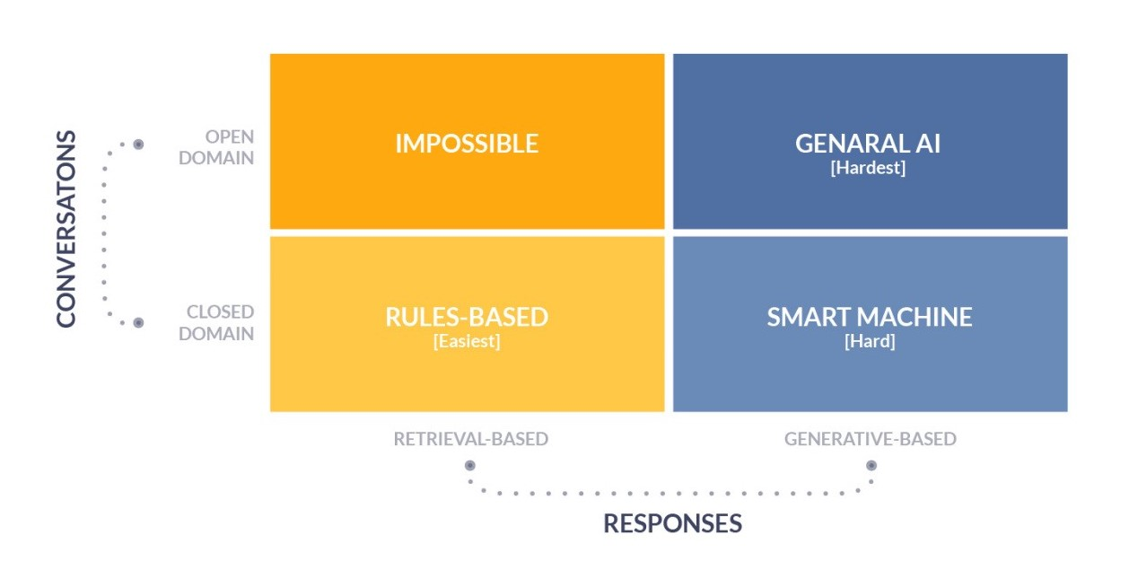

Chatbots are classified using different parameters such as the knowledge domain, service provided, goals, and responses generated.

The knowledge domain is based on the knowledge the Chatbot accesses. There are two types of domains; the open and the closed domains.

* The open domain chatbots address general topics and respond appropriately to general questions. They are used to retrieve general information like general knowledge, weather forecast, etc. Examples: Alexa of Amazon, Cortana of Microsoft, Siri of apple or Google assistant.
* The bots in the closed domains address specific knowledge domains and may fail to respond to questions from other domains.

The service-based Chatbots are categorized into those that offer interpersonal, intrapersonal and inter-agent services.

The goal-based Chatbots are further categorized under the informative, conversational and task-based Chatbots.

The last category includes the Chatbots based on the input method and the responses generated. There are Chatbots that accept input, and process and generate output in natural language, and others that are rule-based as they process input based on rules. Other Chatbots in this category are a hybrid as they use natural understanding and rules to process input and generate output.

**LITERATURE REVIEW**

**Artificial Intelligence**

Current technological advancements have placed Artificial Intelligence (AI) at the focal point of research and innovation. The integration of AI in our lives requires the distinction between weak AI and Artificial General Intelligence (AGI). Weak AI refers to computer programs developed to solve specific problems like playing chess or conducting facial recognition. The programs in weak AI employ AI techniques such as data mining and machine learning. AGI refers to flexible machines that can provide solutions to problems just like a human being. The majority of current AI inventions mostly dwell on weak AI and a few on AGI. The adoption of AGI is still in the initial stages but much advancement is expected within the next two decades.

**Chatbots**

A Chatbot is an artificial intelligence (AI) based software program that is able to simulate a conversation with the user using natural language through messaging platforms, phone applications and websites. Users interact with Chatbots that have a conversational user interface (CUI), which allows users to interact with the bot. This means that the users do not have to download any applications onto their devices or launch any specific applications. CUI are intuitive and easy to use.

**Usage of Chatbots in India**

India has widely embraced the use of Chatbots in various sectors and it is a key player in the Chatbot market.

In the banking sector, Chatbots are used to handle customer queries (and FAQs) and give guidance on bank services and products. Chatbots in the banking sector include SIA, iPal and EVA by the State Bank of India, ICICI Bank and HDFC Banks respectively.

In the insurance sector, Chatbots are assisting customers in filing claims, getting policies, checking the status of their policies, and locating providers and their branches, as well as other service providers. Baja Allianz’s Boing, Birla Sunlife’s bot and PNB Metlife’s banking applications are among the commonly used Chatbots in this sector.

In the transport sector, Chatbots are used to provide realtime cab details, flight bookings and verifications, and traffic analysis. Meru Cab and Yatra.com Chatbots are among the bots used in the transport sector.

In the ecommerce sector, Chatbots have been used in handling queries, tracking orders, making payments and raising customer complaints.

**THEORY**

The increase in the computing power has paved the way for new technological advancements. Artificial intelligence has played a very crucial role in these technological advancements. One of the important applications of artificial intelligence is Natural Language Processing. Natural Language Processing is a method of making the machine or a computer understand the human language. And, one of the important applications of Natural Language Processing is Conversational Agents, also called as Conversational Artificial Intelligent Bots or it can be simply called as Chatbot Systems.

Chatbot is a computer program designed to be able to interact with humans through text or voice messages. Chatbot is usually also equipped with artificial intelligence and natural language processing which makes it an intelligent computer program.

In the recent times chatbot systems have gained popularity because of its wide applications. Apart from the wide range of applications the reason for the popularity of chatbot systems is that they are approachable, they enhance customer experience, they can manage large number of customers, and are very cost effective. It has been observed that chatbot systems helps in reducing the overall operating costs as well. In the coming years it is expected that chatbot systems will reduce the workload at the higher management levels by up to 70%. Because of this corporations are expected to invest billions of dollars in the research and development of chatbot systems. Even from the customer’s point of view chatbot systems present a unique experience of availability of help and support for a product anytime of the day. This helps the overall customer experience. As a matter for fact, it has been observed that consumers prefer chatbot systems over human interaction and going ahead would prefer these systems over physically visiting the stores. These chatbot systems are given knowledge, with the help of which these systems try and answer user’s queries.

**Chatbot architecture**

1. **Client Module:** the part of the chatbot that the user interacts with along with all the applications the chatbot can control.
2. **Communication Module:** the infrastructure that transmits user messages from the client module to the response generation module and from the response generation module to the database module.
3. **Response Generation Module:** the program responsible for actually understanding the input message and generating an appropriate response for the user.
4. **Database Module:** the place where all the data relevant to a conversation is stored, such as message history, photos, and user preferences.

**Applications of Chatbot**

* **Education**

Advancement in the education sector is essential to accommodate evolving lifestyles, economy, technology and student’s needs. Also, the increased scarcity of quality teachers in the education system have made the integration of advanced technology in our education system essential. Research indicates that the education sector can benefit from Chatbot development. Chatbots will assist in solving some of the current challenges facing the education sector.

Chatbots have been in use for educational purposes for quite some time. These Chatbots can be categorized into those with education intentionality and those without. Chatbots without education intentionality are used in administrative tasks such as student guidance and assistance. Chatbots with education intentionality are used in fostering teaching and learning. Within this category, there are Chatbots which provide the framework of the learning process, that is, select and arrange contents to fit the students’ needs and speed, and help in reflection and learning motivation. These bots act as a learning companion which provides dialogue, collaboration and reflection. Furthermore, there are exercise and practice Chatbots that present a stimulus in question form, to which the student provides an answer that is assessed by the Chatbot which then provides feedback. Chatbots enhance dialogic learning as it is based on a communicative exchange between the bot and the student. The Chatbot initiates a conversation by asking a question, the students discuss the question and give a response, and the bot provides feedback.

* **Healthcare**

Healthcare is very important to lead a good life. Today’s people are more likely addicted to internet but they are not concerned about their personal health. In their busy life, they forget to take suitable measures to maintain their health. In the latest news by TOI, we can see that people give no importance to their health and find it time consuming to undergo check-ups at hospitals. Most people comprising the working section of the society claim that their hectic schedule gives them no time for periodic medical check-ups. People avoid hospital treatment for small issues which may become a major disease in future.

However, chatbot can make it easier for people to check on their health as compared to the conventional way of standing in a queue for hours before they could get their medication done. People can interact with the chatbot just like they do with another human and through a series of queries, chatbot will identify the symptoms of the user and thereby, predicts the disease and recommends treatment. It can be of great use to people in conducting daily check-ups, makes people aware of their health status and encourages people to take proper measures to remain healthy. It is meant to help and deliver immediate actions where humans cannot reach due to timing or budget as it is readily available and free of cost.

An important aspect of the chatbot is that talking with a non-human entity provides a sense of security especially when it comes to mental health as it remains as a confidential meeting with the diagnosis being available only to the user. This helps users to be more open with their health matters and paves way for chatbot to efficiently identify the disease.

* **E-commerce**

The rise of e-commerce over the past two decades had a major impact on society and the way business is done on a global scale. Along with revolutionizing the retail industry this industry has many positive impacts on both the business and on consumers on a personal level. Users have become more relied on e-commerce than ever before in the recent years.

There's one visible downside about using e-commerce as a means to sell your products could be that some customers are wary of not having direct face to face contact with a sales representative. This is particularly apparent with the older generation who are not digital natives. The other issue that might put people off from buying online is that there is not as much opportunity to speak with someone about the product. A customer may have a lot of queries for an online e-commerce store, this could only be represented as a circumpolar struggling point. A lot of e-commerce giants have taken the steps to hire customer supports who would provide live chat support. However, this is a very expensive option and since the customer traffic is always unpredictable, it is never possible for them to serve 100% of their customers. Other attempts have been to develop Chatbot to answer basic FAQ questions. Chatbot can announce the status of the shipping of the product after payment is made by the customer. It can also make recommendations on the basis of previous transactions, remind users of any product they want to know about, or ask questions to provide details on the product they are looking for according to their interaction.

**Privacy Risks of Chatbot Conversations**

With chatbots gaining traction and their adoption growing in different verticals (e.g., Health, Banking, Insurance, etc.) and users sharing more and more private information with chatbots - studies have started to highlight the privacy risks of chatbots.

Let us consider the privacy risks posed by queries with respect to the user's location. Most chatbots are usually designed/deployed for specific regions. For example, an HR Info bot might be designed for the locations where the company has offices. Similarly, an e-commerce bot would also be deployed in only those countries where the vendor currently ships products. Given a query such as "Hi, I am currently in Geneva. What are the shipping charges for Geneva?" unnecessarily reveals the user's location given that the vendor does not deliver in Geneva. In an organizational context, with an HR chatbot maintained by an outsourced vendor, deployed in Geneva and Krakow; frequent employee queries of the form: "Where is the restaurant in our Milan office?" might reveal to the vendor that company employees have recently been traveling a lot to the Milan office. Traditional security mechanisms such as restricting access to the chatbot logs (via encryption, access control policies, etc.) are not sufficient; as the logs need to be analyzed for continuous improvement of the bots.

**PROPOSED WORK**

One of the most important demography which has been conveniently ignored are the elders. Due to many compulsions, it is not possible to sit with the elderly and have a good conservation. So, we propose to build a chatbot system which engages the elderly people in small talk and conversation. For this we are using message and its response pairs. This chatbot system uses the Python programming language because it is easier to understand. Python has extensive support libraries.

**ARCHITECTURE**

**RECURRENT NEURAL NETWORKS**

RNN can be seen as a sequence of neural networks. A recurrent neural network (RNN) is a type of artificial neural network which uses sequential data or time series data. These deep learning algorithms are commonly used for ordinal or temporal problems, such as language translation, natural language processing (NLP), speech recognition and image captioning. Like feedforward and convolutional neural networks (CNNs), recurrent neural networks utilize training data to learn. They are distinguished by their “memory” as they take information from prior inputs to influence the current input and output. While traditional deep neural networks assume that inputs and outputs are independent of each other, the output of recurrent neural networks depend on the prior elements within the sequence.

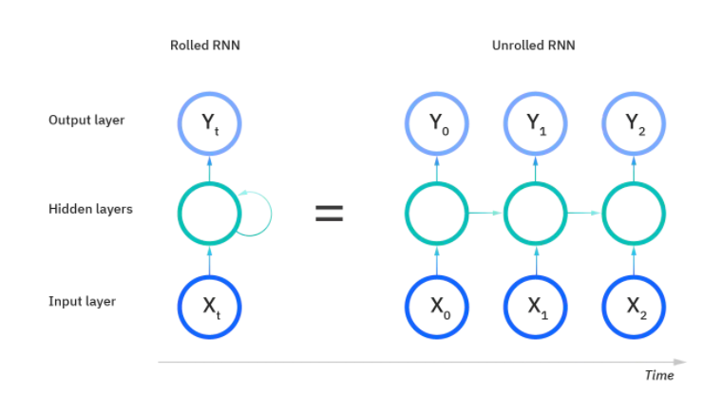

While feedforward networks have different weights across each node, recurrent neural networks share the same weight parameter within each layer of the network.

**LONG SHORT-TERM MEMORY NETWORKS (LSTM)**

This is a popular RNN architecture, which was introduced by Sepp Hochreiter and Juergen Schmidhuber as a solution to vanishing gradient problem. They work to address the problem of long-term dependencies. That is, if the previous state that is influencing the current prediction is not in the recent past, the RNN model may not be able to accurately predict the current state. As an example, let’s say we wanted to predict the italicized words in following, “Alice is allergic to nuts. She can’t eat *peanut butter*.” The context of a nut allergy can help us anticipate that the food that cannot be eaten contains nuts. However, if that context was a few sentences prior, then it would make it difficult, or even impossible, for the RNN to connect the information. To remedy this, LSTMs have “cells” in the hidden layers of the neural network, which have three gates–an input gate, an output gate, and a forget gate. These gates control the flow of information which is needed to predict the output in the network.  For example, if gender pronouns, such as “she”, was repeated multiple times in prior sentences, you may exclude that from the cell state.

**SEQ2SEQ MODEL**

The **sequence to sequence (seq2seq) model** is a learning model that converts an input sequence into an output sequence. In this context, the **sequence** is a list of symbols, corresponding to the words in a sentence. Nowadays, it is used for a variety of different applications such as image captioning, conversational models, text summarization, etc. It consists of two RNNs (Recurrent Neural Network), an Encoder and a Decoder. The encoder takes a sequence(sentence) as input and processes one symbol(word) at each time step. Its objective is to convert a sequence of symbols into a fixed size feature vector that encodes only the important information in the sequence while losing the unnecessary information. You can visualize data flow in the encoder along the time axis, as the flow of local information from one end of the sequence to another. Each hidden state influences the next hidden state and the final hidden state can be seen as the summary of the sequence. This state is called the context or thought vector, as it represents the intention of the sequence. From the context, the decoder generates another sequence, one symbol (word) at a time. Here, at each time step, the decoder is influenced by the context and the previously generated symbols.

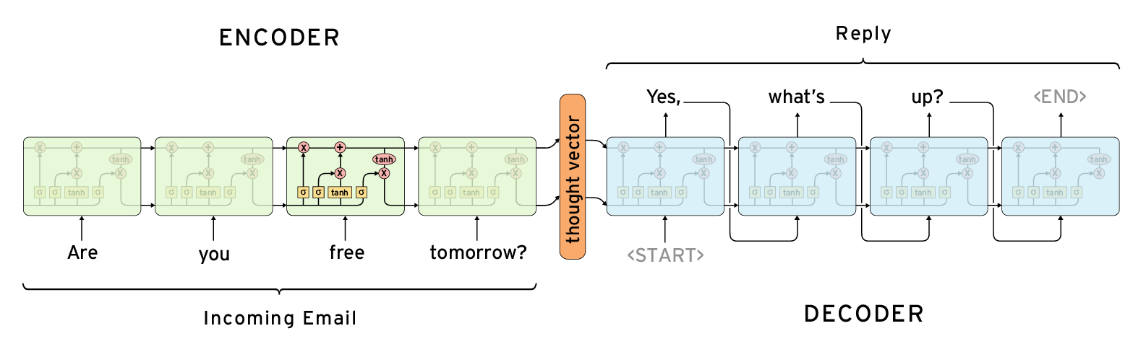

**ATTENTION MECHANISM**

The attention mechanism has changed the way we work with deep learning algorithms. Fields like Natural Language Processing (NLP) and even Computer Vision have been revolutionized by the attention mechanism. The attention mechanism is one of the most valuable breakthroughs in Deep Learning research in the last decade. It has spawned the rise of so many recent breakthroughs in natural language processing (NLP), including the Transformer architecture and Google’s BERT.

One of the limitations of seq2seq framework is that the entire information in the input sentence should be encoded into a fixed length vector, context. As the length of the sequence gets larger, we start losing considerable amount of information. This is why the basic seq2seq model doesn’t work well in decoding large sequences. The attention mechanism was created to resolve this problem of long dependencies. Each time the model predicts an output word, it only uses parts of the input where the most relevant information is concentrated instead of the entire sequence. In simpler words, it only pays attention to some input words.

Attention is an interface connecting the encoder and decoder that provides the decoder with information from every encoder hidden state. With this framework, the model is able to selectively focus on valuable parts of the input sequence and hence, learn the association between them. This helps the model to cope efficiently with long input sentences.

**DATASET**

*Cornell Movie-Dialog Corpus*

This corpus contains a large metadata-rich collection of fictional conversations extracted from raw movie scripts:

* 220,579 conversational exchanges between 10,292 pairs of movie characters
* involves 9,035 characters from 617 movies
* in total 304,713 utterances

movie_lines.txt

- contains the actual text of messages and its response pairs.

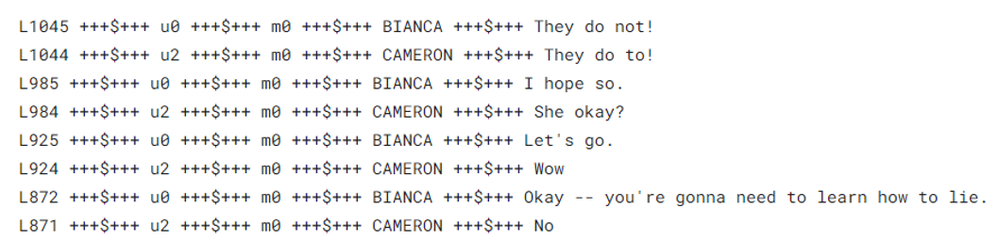

" +++$+++ " is the field separator in the file.

**DATA PREPROCESSING**

The datasets were cleaned to remove the meta-data (e.g., movie ID, character ID, Line ID) and data separators (“+++$+++”). Some of the characters in the data contained an unsupported encoding format by UTF-8 standard and hence were removed. Finally, data were separated into two different lists where first list is the dialogue (or questions) and the second one was the response to dialogue (or answer).

The data of both lists was then cleaned simultaneously. Everything except alphabetical character and some punctuation (. , ? ! ’) was removed as they hold little meaning in conversation. Also, all the text was converted to lowercase. Then, multiple consequent occurrences of the punctuations (. , ? ! ’) was reduced to one in order to reduce punctuation overload. Next, all the punctuation except (’) was separated with a single space before and after for better performance in the Seq2Seq model module. Finally, all the consequent multiple spaces were reduced to single space and each text string was trimmed to remove before and after space. Also, data was cleaned for removing extraneous dialogues. Filter the question and answers that are too short or long. The most frequent words in the training data were kept as vocabulary. Additionally, the <PAD> token was used for padding input sequences to same lengths, the <EOS> token was used to signal the end of an utterance and the <UNK> token was used to replace all words not present in the vocabulary. <GO> was given to the start of the sentence.

**TRAINING**

Training is a long process which demands higher processing power and configured computing machine. We created filtered question and answer list. The input and output of our model will be the filtered questions and answers. We split our data into training and testing sets with respect to batch size. The model was then trained on the training dataset using Adam optimizer as it can compute individual adaptive learning rates for different parameters from estimates of first and second moments of the gradient. BidirectionalLSTM was used in encoder side and attention mechanism was used in decoder side to improve model performance.

**TESTING**

The model was loaded to make prediction on the validation set that we have created earlier. The validation set was used to test how well our model performs on new, never before seen data.

**RESULT**

The model can be limited in performance regarding long conversation. Many of the output were repetitive and generic. Also, due to lack of real-life quality data the chatbot performed somehow below optimum for imitating human interaction. Also, many utterances were discarded due to longer length or discrepancy.

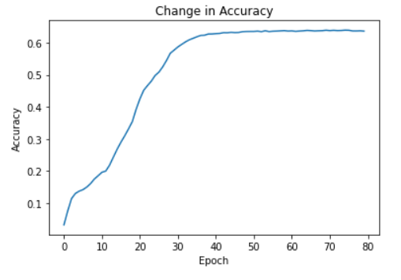

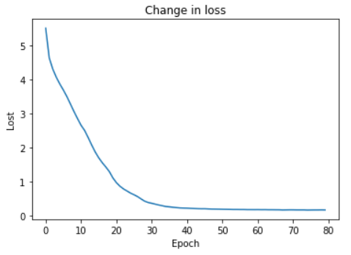

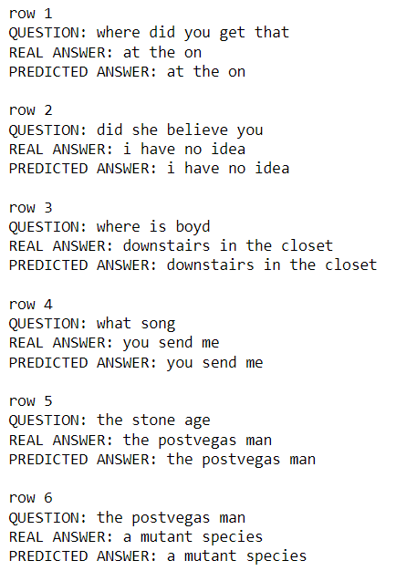 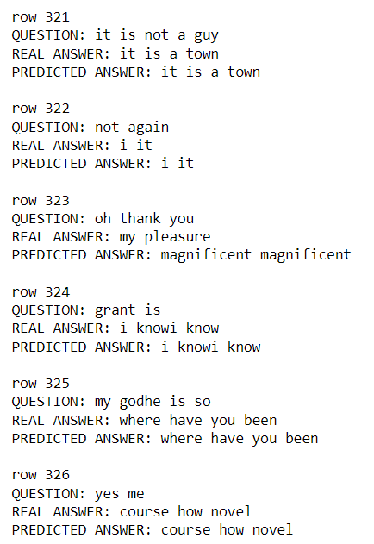

**CONCLUSION**

We were able to develop a Seq2Seq AI Chatbot. Various techniques and architectures were discussed to make conversational agents more natural and human-like. The performance of the model was analyzed by comparing output responses for a set of source utterances. To get better results, we can try different combination of hyperparameters. We can also try different attention mechanism like Luong.

Many different machine learning or deep learning methods can be explored in order make the chatbot systems more accurate. As a matter of fact, the basic natural language processing tasks can be explored further in order to make the data more suitable for further analysis. Also, the field of processing of unstructured data, which is text data given as a knowledge is yet to be explored in an effective way. So, it can be concluded that there is ample scope for research in this area of natural language processing.

**REFERENCES**

1. Abonia Sojasingarayar, “Seq2Seq AI Chatbot with Attention Mechanism”, Jun 2020
2. Nitirajsingh Sandu and Ergun Gide, “Adoption of AI-Chatbots to Enhance Student Learning Experience in Higher Education in India”, 2019 18th International Conference on Information Technology Based Higher Education and Training (ITHET)
3. Rohit Binu Mathew, Sandra Varghese, Sera Elsa Joy and Swanthana Susan Alex, “Chatbot for Disease Prediction and Treatment Recommendation using Machine Learning”, 2019 3rd International Conference on Trends in Electronics and Informatics (ICOEI)
4. Mohammad Monirujjaman Khan, “Development of An e-commerce Sales Chatbot”, 2020 IEEE 17th International Conference on Smart Communities: Improving Quality of Life Using ICT, IoT and AI (HONET)
5. https://www.ibm.com/cloud/learn/recurrent-neural-networks